# Course: web technnology

TOPIC:

Prison Management system

**ID:23354**

**NAMES: Uwamahoro Rebecca**

## Introduction

* 1. The management and administration of prisons play a critical role in ensuring the security, rehabilitation, and effective functioning of correctional facilities. Over the years, the increasing population within prisons, complex inmate management requirements, and evolving legal frameworks have created a pressing need for efficient and streamlined prison management systems. In response to these challenges, this project aims to develop a comprehensive prison management system that leverages technology to enhance the overall operations and effectiveness of correctional facilities

As you can see this is how our system 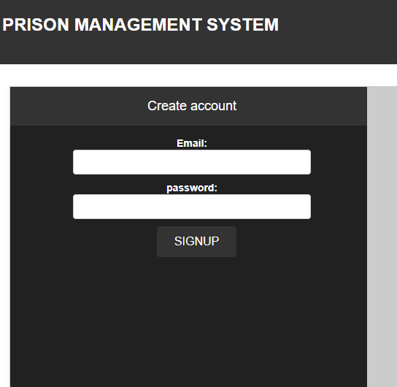

As first user on our website you as you can see you may SIGNUP by creating a new account

* 1. 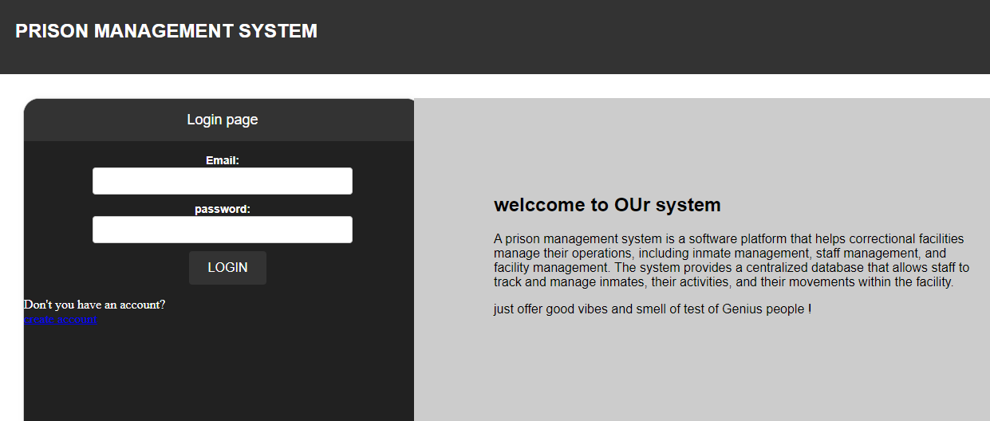

## **register prison**

